National Immunization Awareness Month

**Week 1: Truth Doesn’t Change**

**Friday, August 1st**

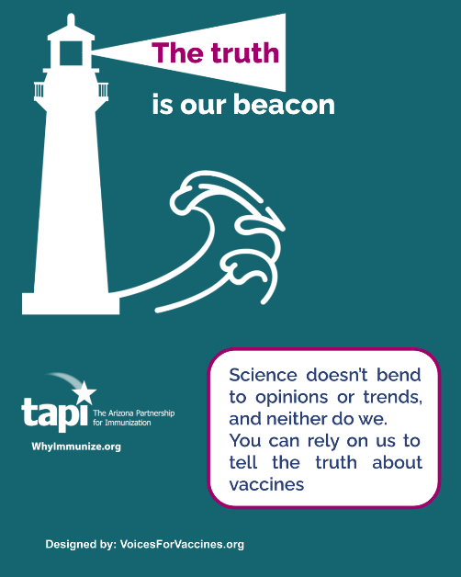

* **Caption 1:**Headlines change, but the measles vaccine still prevents measles. The polio vaccine still prevents polio. They worked for our parents, and they’re still working for us today. #NIAM2025

**Saturday, August 2nd**

Post one of the following articles from families affected by measles.

* **Caption 1:**“When you talk about someone who becomes brain injured from measles encephalitis, you’re talking about a very complex situation.”

How Emmi and Marcie’s whole lives were changed by measles. <https://youtu.be/PcqbxE5yMyY?si=MnhkjztDzq7KMp2x> #NIAM2025

* **Caption 2:** “Seeing measles come back shook me hard…If you could prevent the chance of this happening to your child, why would you even question that?”

Anita hoped that her family’s measles experience was a thing of the past. <https://www.voicesforvaccines.org/what-measles-sspe-did-to-my-family/> #NIAM2025

**Week 2: Proof Positive (Vaccines Work)**

**Tuesday, August 5th**

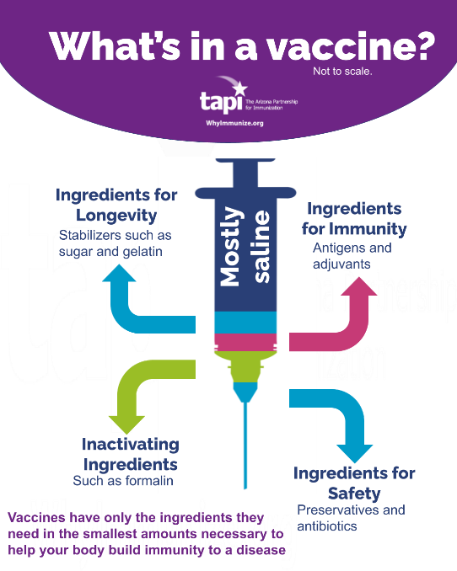

* **Caption 1:** Being informed about vaccines means knowing that ingredients like gelatin and aluminum aren’t scary—they’re there for specific, science-based reasons. Knowledge beats worry every time. #NIAM2025

**Wednesday, August 6th**

Share one of our graphics with a quote from a vaccine hero, or put in one of your own!

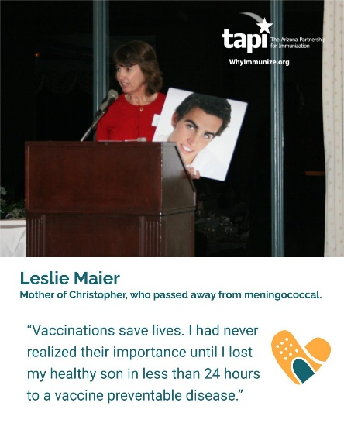

* **Caption:**[Name] stands up for science, truth, and public health when it matters most. That’s the kind of courage that saves lives. Who out there is a public health champion to you? #NIAM2025

**Thursday, August 7th**

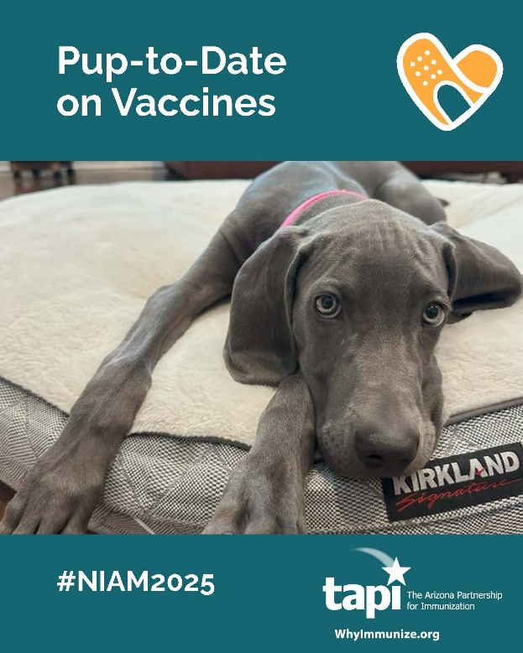 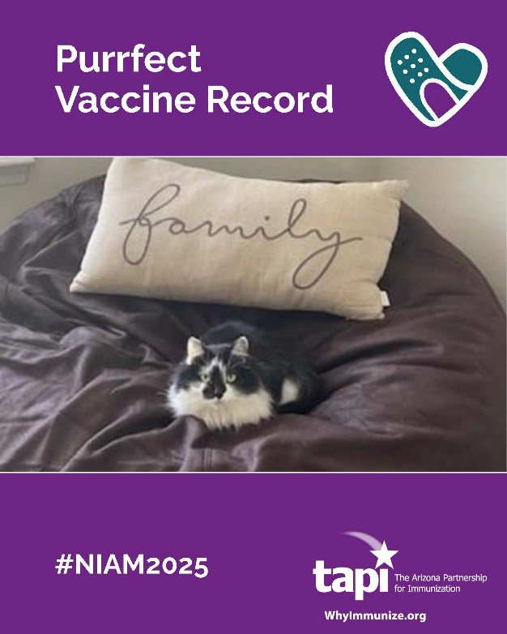

* **Caption 1:** Before vaccines, rabies and parvovirus were heartbreaking realities for pet families. Now they’re just items checked off at the vet. That’s progress worth barking about. #NIAM2025
* **Caption 2:** Vaccines protect our pets from serious diseases like rabies, parvovirus, and feline leukemia. Keeping them healthy keeps our families complete. #NIAM2025

**Friday, August 8th – Sunday August 10th**

Share one of these articles highlighting a positive development for vaccines this year.

* **Caption 1:** Less than two years after RSV vaccines and preventive treatments became available, infant hospitalizations are already plummeting. This is prevention working exactly as intended.

<https://www.cidrap.umn.edu/respiratory-syncytial-virus-rsv/rsv-prevention-products-tied-lower-infant-hospitalization-rates> #NIAM2025

* **Caption 2:** The same technology that protects us from infectious diseases is now being designed to fight cancer. Vaccines keep fighting to make us healthier and healthier.

<https://youtu.be/TVqLoobmvG0?si=2Hi86FPa9EavcyWL> #NIAM2025

**Week 3: The Pro-Vaccine Majority**

**Tuesday, August 12th**

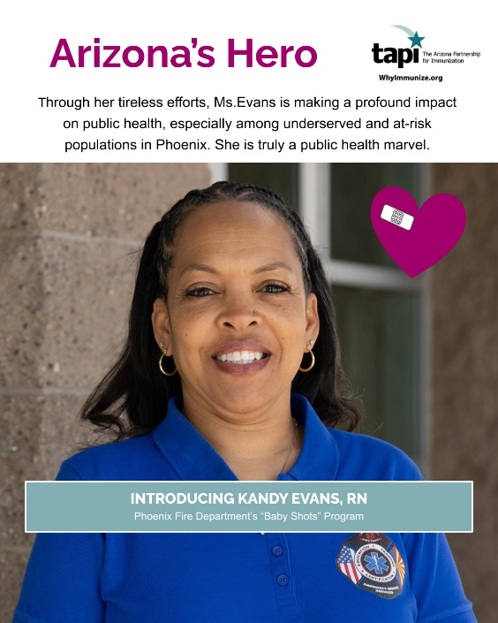

**Caption 1:**When Kandy Evans, RN shows up to work, kids get protected from preventable diseases. That’s how prevention becomes reality in Arizona.

#NIAM2025

**Friday, August 15th**

**Caption 1:** Vaccines have science on their side, but they also need advocates on their side. Here are some organizations you can support that do work on pro-vaccine policy.#NIAM2025

**Week 4: The State of Play**

**Tuesday, August 19th**

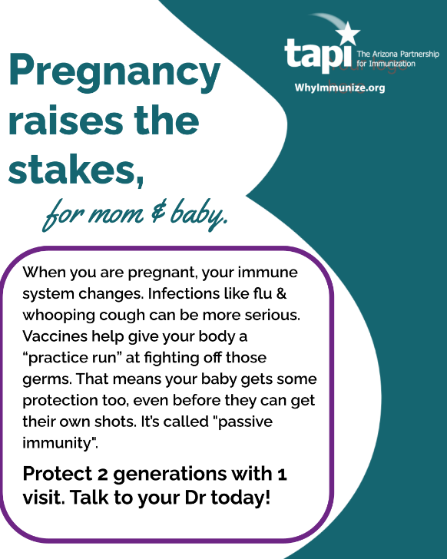

**Caption 1:** While pregnant, it can be easier to get very sick from certain infections, even if you’ve always been healthy before. Vaccines help your body get ready to fight those germs safely, and your baby gets some of the protection too, before they are born. #NIAM2025

**Caption 2:** When you’re pregnant, diseases hit harder than you’re expecting. Vaccines help fill the gap while your immune system is stretched. #NIAM2025

**Thursday, August 20th**

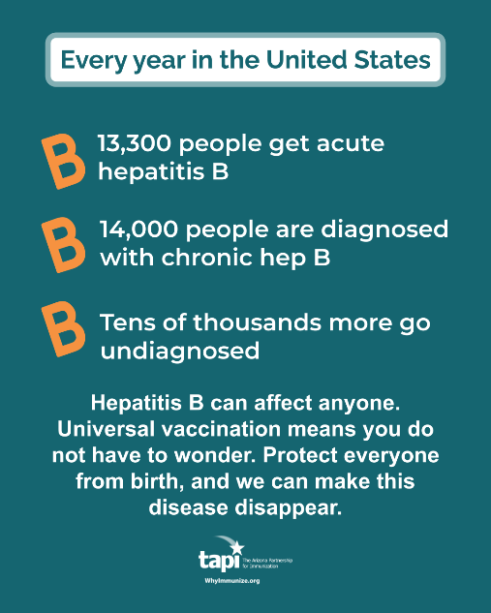

* **Caption 1:**Hepatitis B can affect anyone, but universal vaccination means no one has to wonder if they’re protected. Protect everyone from birth, and we can eliminate this disease entirely. #NIAM2025

**Friday, August 22nd**

Post one of these questions for your audience. If you’d like, you can include your own example of someone you vaccinate for.

**Caption 1:**We’re asking: Who do you go home to that makes your vaccination decision really matter?

Maybe it’s your mom on immunosuppressants, your kid with a transplant, or your partner fighting cancer. When you vaccinate, you’re protecting their life. Who comes to mind for you?

**Caption 2:**Question: Who in your life depends on your immunity to stay healthy?

Is it your spouse undergoing chemo? Your grandparent with heart disease? Your best friend with an autoimmune condition? Your vaccination could be what keeps them out of the hospital. Share your story.

**Week 5: The Difference THIS YEAR**

**Monday, August 25th**

**VFC Caption:**The Vaccines for Children program isn’t just policy—it’s proof that America has long believed vaccination is so important that cost should never be a barrier. That’s the kind of commitment that saves lives. #NIAM2025

**Task Force Caption:** Through organizations like The Task Force Global Health, America has been at the forefront of getting vaccines to kids worldwide. That work has saved millions of lives and is something to be proud of. #NIAM2025

**Wednesday, August 27th**

Share this graphic emphasizing how vaccines are important to help kids healthy and in school.

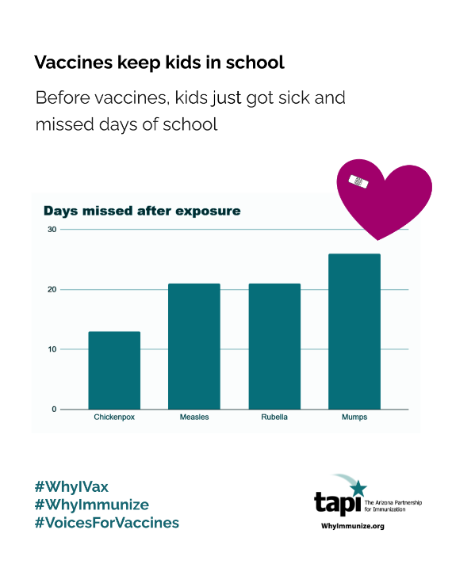

* **Caption:**Vaccines turned “outbreak” from a word that emptied schools into just another thing kids learn about in health class. They don’t need a real-life example. #NIAM2025

**Sunday, August 31st**

Make a post saying thanks to your followers, and include a picture of your team.

**Caption:** Thank you all for a wonderful #NIAM2025 🙌

Vaccines protect us all the time, so we’ll keep sharing more about them long after August. But to end the month, here is the team that keeps us going all year round!