TAPI Toolkits

Get vaccinated now for your COVID-19 vaccine! Check your eligibility here: COVID-19 Vaccine | Maricopa County, AZ.
Register for and schedule your vaccine by phone 1-844-542-8201 and online at https://podvaccine.azdhs.gov/.
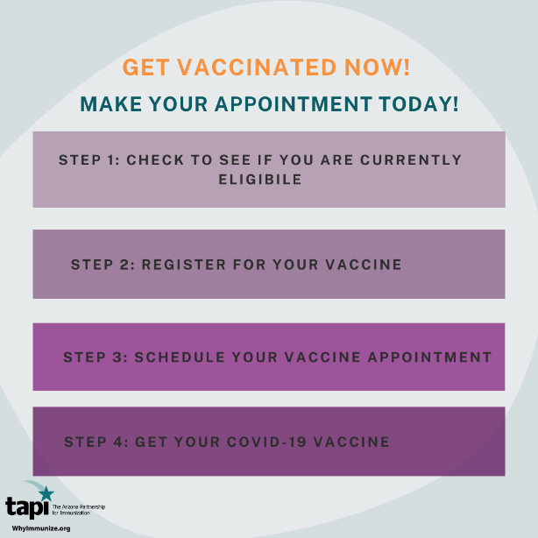

When can you get your vaccine? Find out what tier you are in and what vaccination phase your county is in here: vaccine-phases.pdf (azdhs.gov)
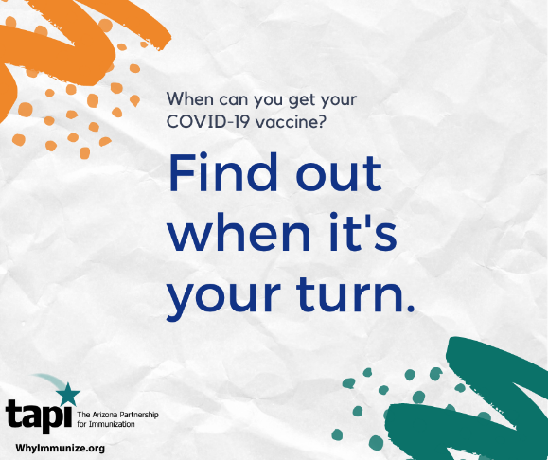

Did you know that you can get COVID-19 and pass it on to others, even without symptoms? Get the latest information about your COVID-19 vaccine facts at www.whyimmunize.org/covid-19-resource-page/ to help stop the spread of misinformation!
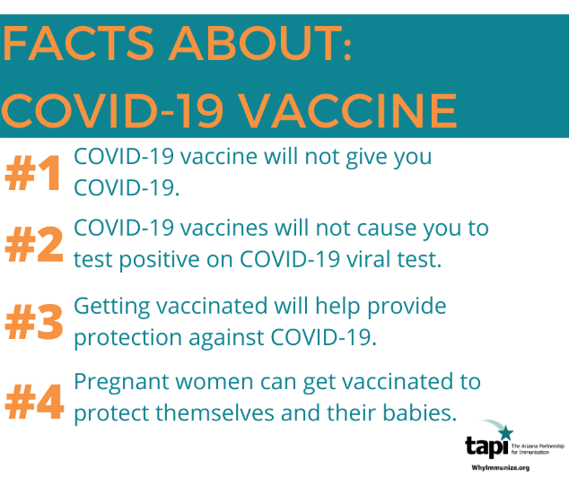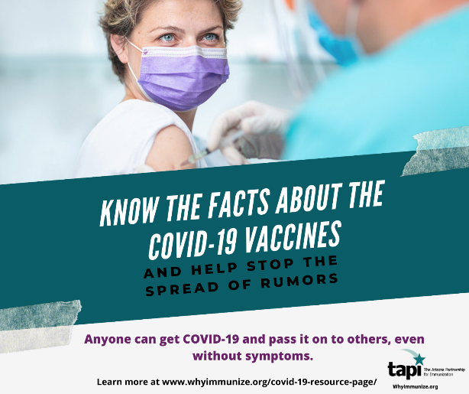

Your mask counts! It is important to give time for our vaccines to work and help prevent the spread of COVID-19 to our loved ones. Get updated information on the COVID-19 vaccine at Coronavirus Disease 2019 (COVID-19) | CDC
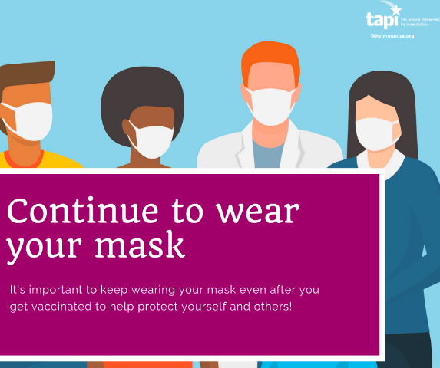

Share your COVID-19 vaccine experience with TAPI at Facbook.com/WhyImmunize. We will highlight your experience!

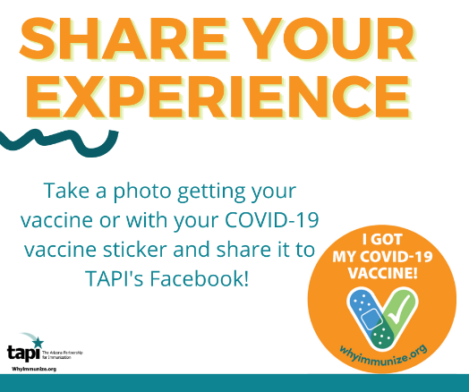

COVID-19 vaccination is available for those aged 55 and older. You can help your older neighbor or family member get their vaccine! Help them register for and schedule their vaccine by phone 1-844-542-8201 and online at https://podvaccine.azdhs.gov/.

People at any age can get COVID-19, even healthy young adults and children. Getting a COVID-19 vaccine may help you from getting seriously ill even if you do get COVID-19.
Get the latest information about the risks of the COVID-19 illness (Things to Know about the COVID-19 Pandemic | CDC) and how the vaccine will help provide you protection (Benefits of Getting a COVID-19 Vaccine | CDC).

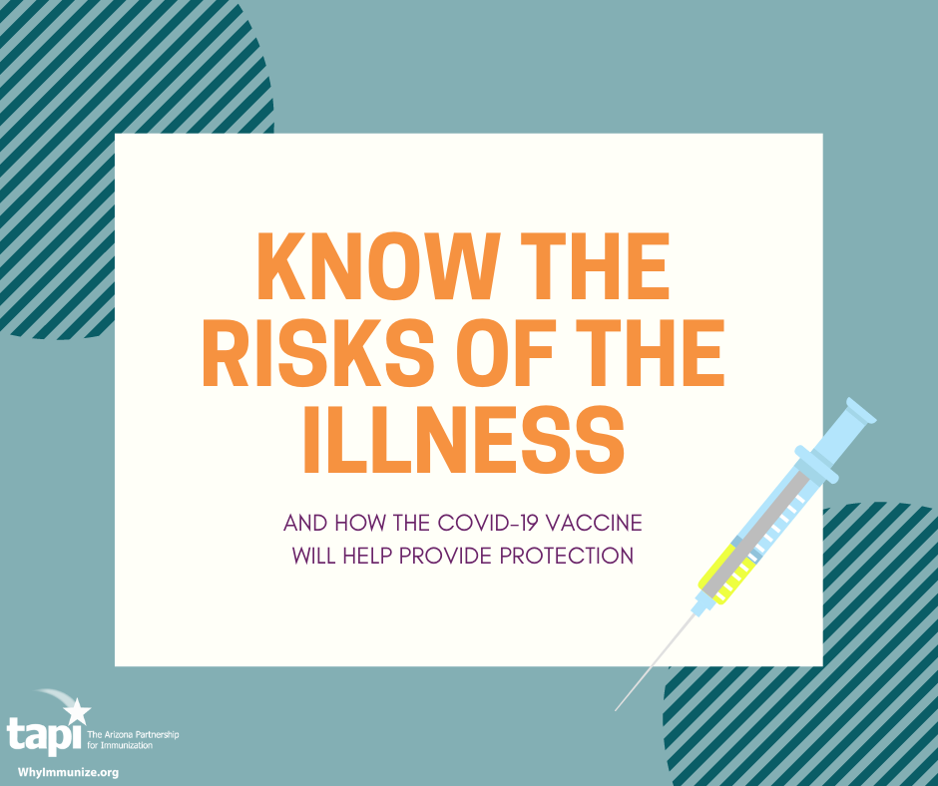

Once you receive your COVID-19 vaccine, you should be provided with information on V-Safe to report on vaccine safety, your vaccine Emergency Use Authorization (EUA) with vaccine facts, and your vaccine card! Learn more on COVID-19 Vaccination Page - Arizona Partnership for Immunization (whyimmunize.org).

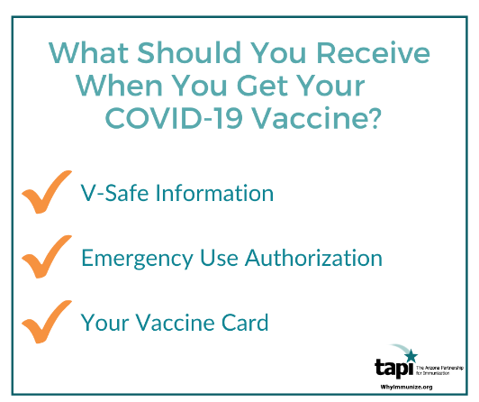

What should you expect after your receiving your COVID-19 vaccine? Common side effects include swelling and pain in your arm where you received the shot, fever, chills, tiredness, and headache. Any other uncommon side effect, such as symptoms increasing or a severe allergic reaction, should be reported to your healthcare provider and V-Safe.

Learn more about what to expect after your vaccine and get V-Safe information here: What to Expect after Getting a COVID-19 Vaccine | CDC

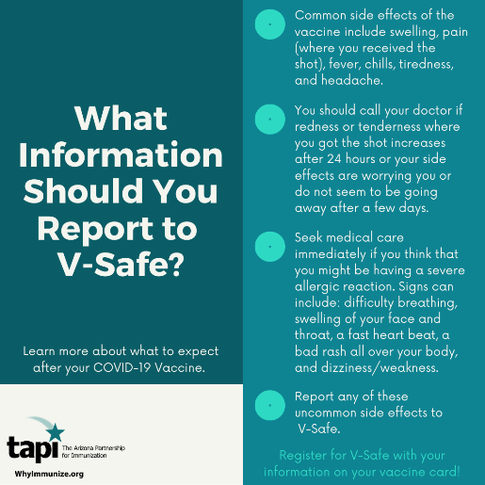

Do you have questions on how to use the state registration system to schedule your COVID-19 vaccine? Visit https://podvaccine.azdhs.gov/help for FAQs on technical support, vaccine safety, priority groups, and vaccine distribution.
View the latest information on vaccine distribution from ADHS: Arizona Department of Health Services | Facebook

