Facts Social Media Talking Points

COVID Vaccines Are Safe.
- Millions of people in the United States have been safely vaccinated.
- These vaccines have the most extensive monitoring in U.S. history.
- Side effects are short term (fever, chills, pain, soreness)

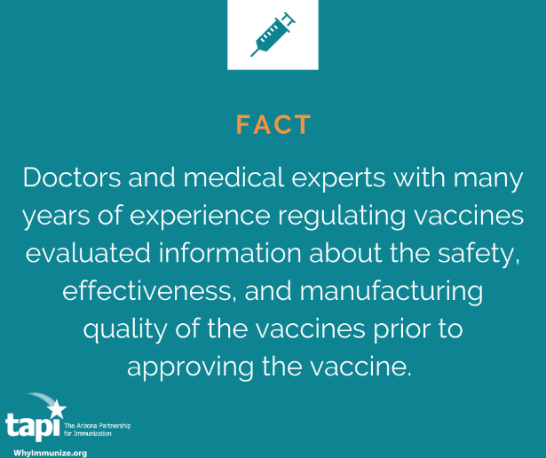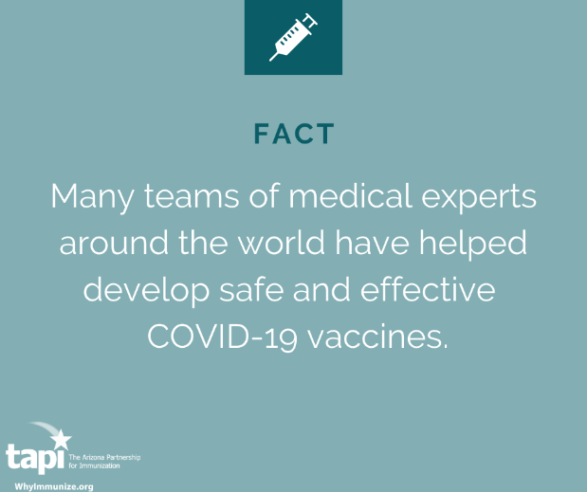

The CDC Investigates Every Reported Death
- Just because something was reported doesn’t mean the vaccine caused it
- The FDA requires providers to report any incidents so they can be investigated
- So far there have been no patterns that show the vaccine is not safe

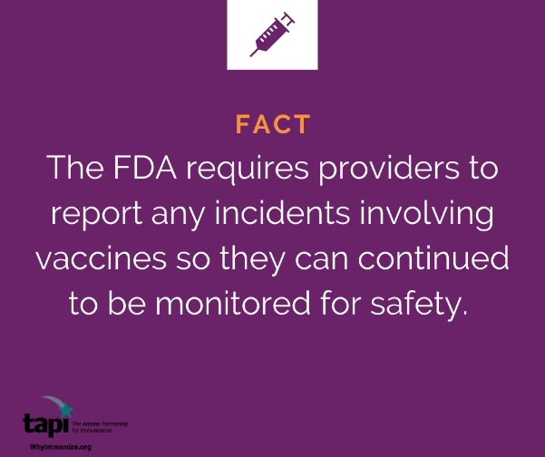

Having different types of vaccines is good
- The government funded many vaccines at once
- Different storage requirements can make certain vaccines a better choice for some communities/populations
- All vaccines have been shown to prevent illness and death
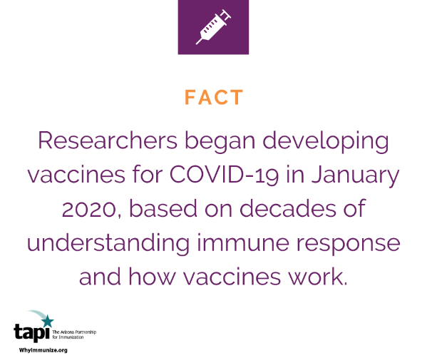

Vaccines haven’t been tested against each other
- Until we can test all of the vaccines against each other we won’t know which one is “best”
- Take the vaccine that you are offered.
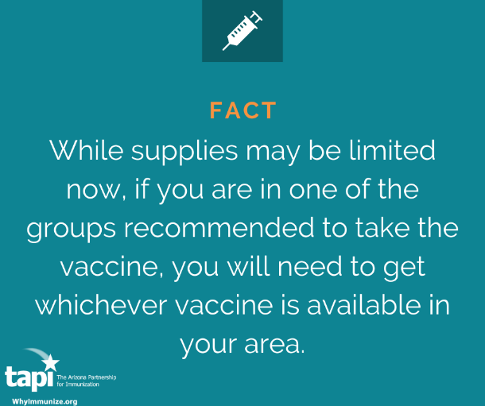

Different Vaccine Are Right for Different Communities due to logistics
- Tray of 1170 doses for Pfizer
- Tray of 100 doses for Moderna
- 2 Fifty Dose Boxes for J&J
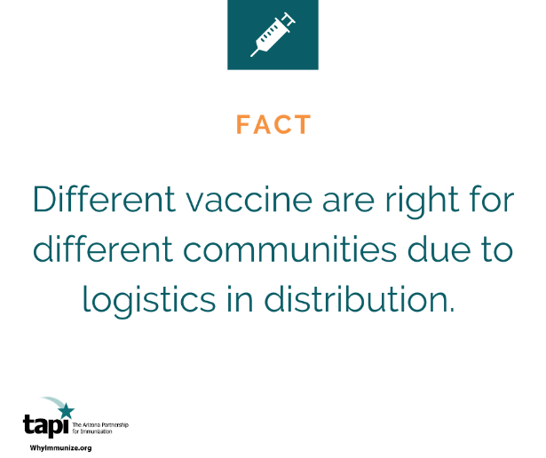

Get the COVID 19 when it is available to you
- Accept the vaccine that is offered to you
- All vaccines protect against COVID

Scaling up Vaccination will be hard, but we are learning and trying to make things better.
- Experts are running this process and will use their knowledge and experience to overcome obstacles.
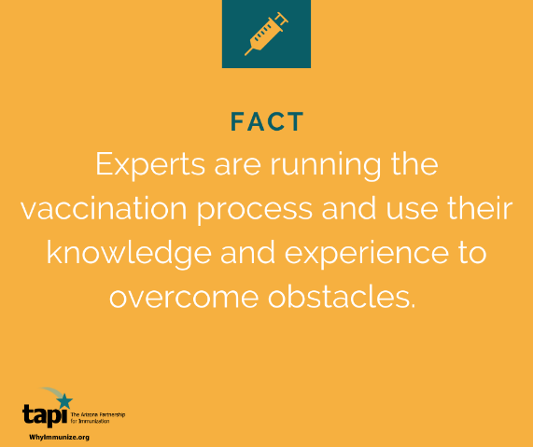

CDC guidelines can be adapted for local use
- Phases are not meant to be absolute.
- Phases can overlap and it is not necessary to end one before starting the next one.
