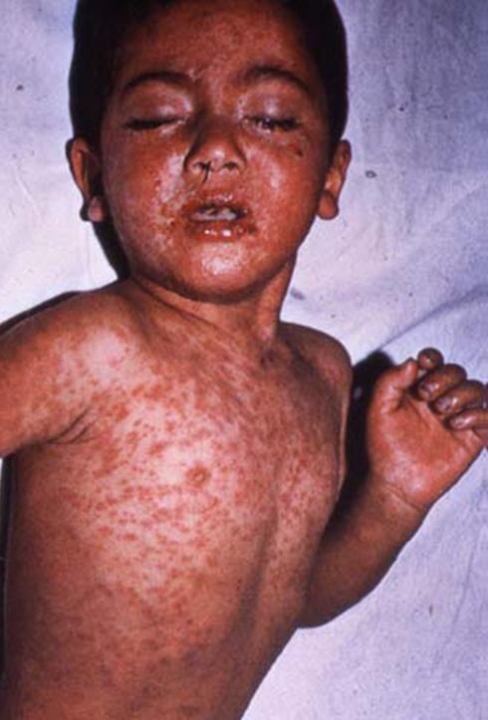
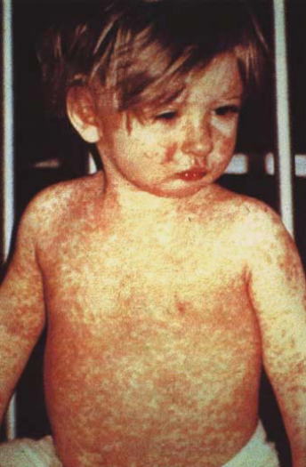
MEASLES
Examples of Measles Cases

What is measles (rubeola)?
Highly infectious viral rash disease. Measles cases are
infectious 4 days before through 4 days after rash onset.
Transmitted by respiratory airborne route.
Disease peaks in late winter and spring.

What are the symptoms of measles?
Prodrome: Fever, cough, coryza, or conjunctivitis.
Koplik’s spots
Rash: Maculopapular rash that becomes confluent.
Begins on face and head, spreads to rest of body, and
will fade in order of appearance

What are complications of measles?
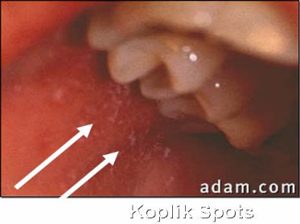
Diarrhea, otitis media, pneumonia, encephalitis, death.
Koplik’s
Spots

What is the disease course?
2-4 days after prodrome

Rash (lasts 5-6 days)
Prodrome
Exposure

Incubation Period: ~14 Days (range 7-21 Days)

1Evidence of Immunity in HCW*
I. Born in or after 1957:
- Documentation of 2 doses MMR**
or live measles vaccine on or after
1st birthday
- Serologic evidence of immunity
(Indeterminate or equivocal results are considered nonimmune)
- Laboratory confirmation of disease

II. Born before 1957:
- Serologic evidence of immunity
(Indeterminate or equivocal results are considered nonimmune)
b) Laboratory confirmation of disease
c) Documentation of at least 1 dose of MMR or live measles vaccine (2 doses strongly recommended, especially during an outbreak)

*May be helpful to also assess immunity to
mumps, rubella, and varicella when
assessing immunity to measles
**MMR vaccine may be advantageous over measles containing vaccine alone because of added protection to mumps

What are the general vaccine recommendations
for Healthcare Workers (HCW)?
All HCW should be immune1 to measles

What are vaccine recommendations during an outbreak
in a healthcare setting?
Born in or after 1957: 2 doses vaccine
Born before 1957: At least 1 dose vaccine for those without serological
evidence of immunity (2 doses strongly recommended)

What should you do if you see a suspected case of measles?
- Immediately place patient in a negative pressure room
or if not available, in a room with a closed door and mask.
- Only allow immune HCW to attend the patient
- Follow standard and airborne precautions
- Inform physician. Evaluate and order measles testing
(Collect serum, urine, and nasal pharyngeal swab
for suspected measles case.)
- Inform Infection Control as soon as possible
- Inform your local health department

Where can I get more information?
- ACIP provisional recommendations for MMR: ‘Evidence of
Immunity’ Requirements for Healthcare Personnel
http://www.cdc.gov/vaccines/recs/provisional/downloads/mmr-evidence-
immunity-Aug2009-508.pdf
- Recommendations for MMR Vaccination:
http://www.cdc.gov/MMWR/preview/MMWRhtml/00053391.htm
- Guidelines for Isolation Precautions:
http://www.cdc.gov/ncidod/dhqp/gl_isolation.html

